Mizaan Work Log
Running human-readable implementation log for local Mizaan work sessions.

2026-05-29 07:20 AM +08:00 ? Phase 4 Page Workspace Foundation

Summary
Phase 4 implemented a provider-backed Notion-like page workspace foundation with breadcrumbs, page header, editable title, editable blocks, properties, relation/backlink/outgoing context, subpages, templates, and right-panel tabs.
The session also repaired prerequisite VaultProvider and vault lifecycle gaps while preserving the active browser localStorage prototype boundary. No SQLite, Tauri, portable folder vault, lock file, cloud, Google, auth, backend, or sync behavior was added.

Files Changed
- Vault provider and lifecycle: src/lib/vault/types.ts, local-storage-vault-provider.ts, use-vault.ts, vault-session.ts, local-items.ts.
- Page model and tests: src/lib/page/page-workspace.ts and page-workspace.test.ts.
- Page UI: src/components/page/PageWorkspace.tsx, PageHeader.tsx, PageBreadcrumbs.tsx, PageProperties.tsx, PageEditorSurface.tsx, PageRightPanel.tsx, PageLinkedContext.tsx, PageSubpages.tsx.
- Routes and shell: src/routes/page.$id.tsx, notes/documents/projects/people/finance/calendar/trackers/templates routes, vault.tsx, settings.tsx, graph.tsx, trash.tsx, index.tsx, __root.tsx, AppSidebar.tsx, TopBar.tsx, CommandPalette.tsx.
- QA and docs: scripts/phase4-browser-qa.mjs, Phase 4 report, Phase 5 blueprint, implementation tracker, self-closer, and screenshots.

Function Changes
Function | File | Before | After
useVaultSnapshot | src/lib/vault/use-vault.ts | Returned provider data directly during render, which could diverge between server memory state and browser localStorage. | Returns a stable hydration snapshot first, then loads the browser provider snapshot after mount and subscribes to provider changes.
buildPageWorkspaceModel | src/lib/page/page-workspace.ts | Read provider snapshot directly inside the model builder and used the provider again to decide missing state. | Accepts a snapshot, normalizes item/block/relation context from that snapshot, builds breadcrumbs, child pages, relation backlinks, outgoing links, properties, and missing state deterministically.
createPageFromTemplate | src/lib/page/page-workspace.ts | Template cards were not guaranteed to create real provider-backed pages. | Creates a real item, writes starter blocks through the provider, and opens the page workspace.
createChildPage | src/lib/page/page-workspace.ts | Nested page behavior was mock/static or absent. | Creates a real provider item with parentId, starter block, and parent-child relation.
PageEditorSurface.addBlock | src/components/page/PageEditorSurface.tsx | Block insertion was visual-only in the old editor surface. | Creates provider-backed blocks, supports Enter-to-add, to-do checked state, and slash command insertion for implemented block types.
CommandPalette actions | src/components/CommandPalette.tsx | Palette actions could expose non-working or mock-driven behavior. | Actions now create/open real provider pages and navigate to working Vault, Settings, and Graph routes.

Spaghetti Cleanup Notes
- Replaced mock-only item lists with provider-backed item/block/relation reads. (spaghetti code cleared)
- Centralized page workspace model normalization, template creation, breadcrumbs, and relation context in src/lib/page/page-workspace.ts. (spaghetti code cleared)
- Removed obsolete mock editor/right-panel surfaces after the page workspace owned those responsibilities. (spaghetti code cleared)
- Fixed render-time provider reads that caused server/client hydration divergence. (spaghetti code cleared)

Screenshots

Home route after Phase 4
Screenshot filename: 20260529-0705-phase-4-home.png
Date/time: 2026-05-29 07:05 AM +08:00
Shows the provider-backed home surface, prototype vault health, recent pages, and local quick actions.
Route/page shown: Home route after Phase 4
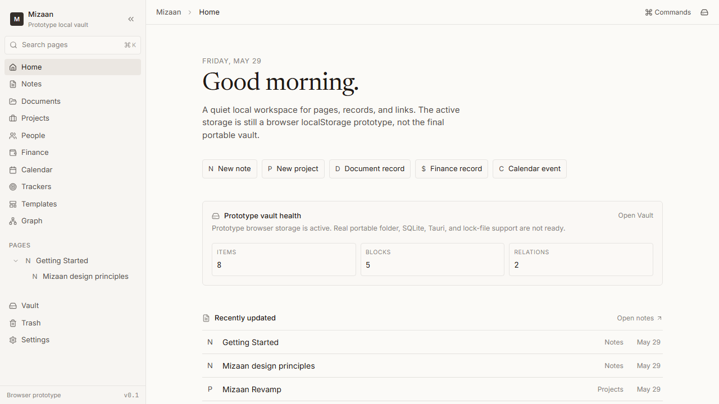

Notes space / page list
Screenshot filename: 20260529-0705-phase-4-notes-space.png
Date/time: 2026-05-29 07:05 AM +08:00
Shows the provider-backed Notes list and template actions before opening the page workspace.
Route/page shown: Notes space / page list
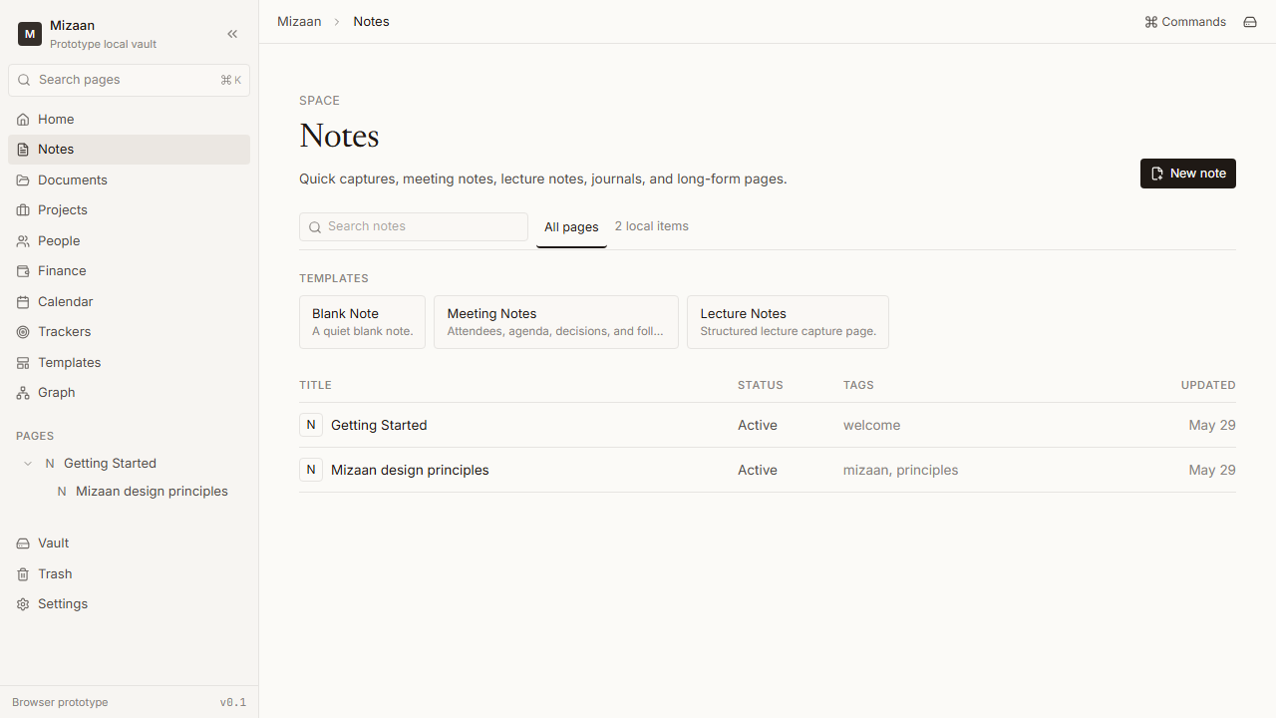

Page workspace
Screenshot filename: 20260529-0705-phase-4-page-workspace.png
Date/time: 2026-05-29 07:05 AM +08:00
Shows breadcrumbs, page header, editable title, properties, block editor, and the right panel foundation.
Route/page shown: Page workspace
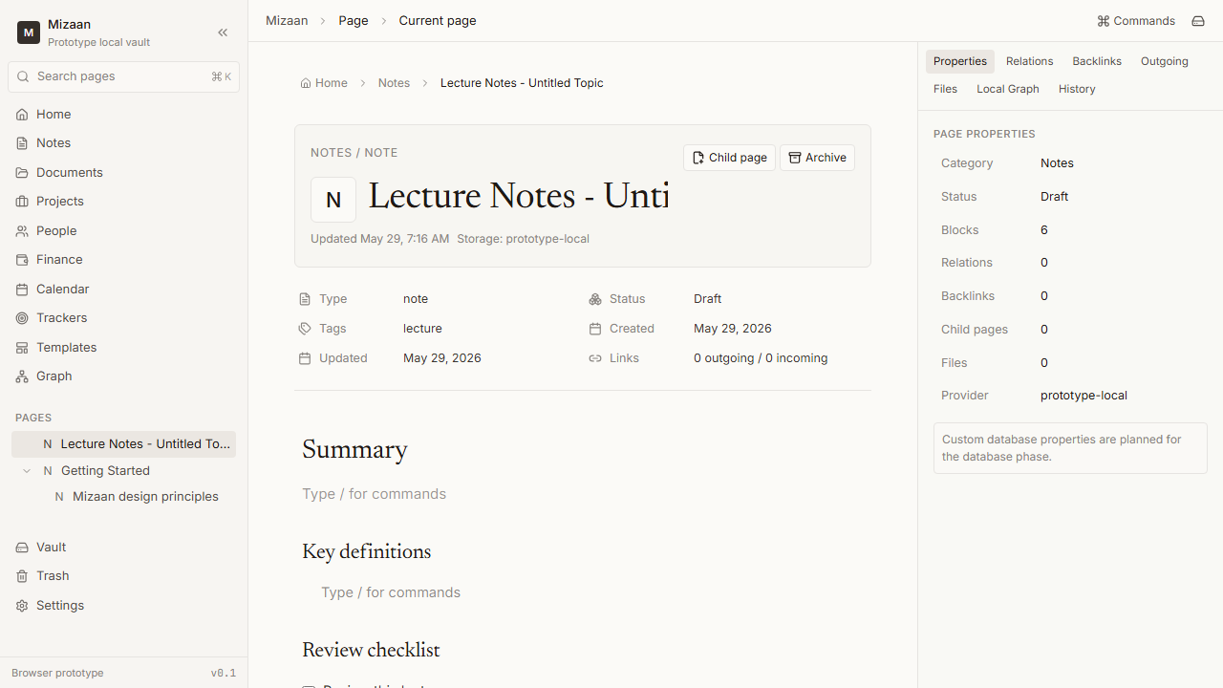

Slash command menu
Screenshot filename: 20260529-0705-phase-4-slash-menu.png
Date/time: 2026-05-29 07:05 AM +08:00
Shows the implemented block command menu used during browser QA.
Route/page shown: Slash command menu
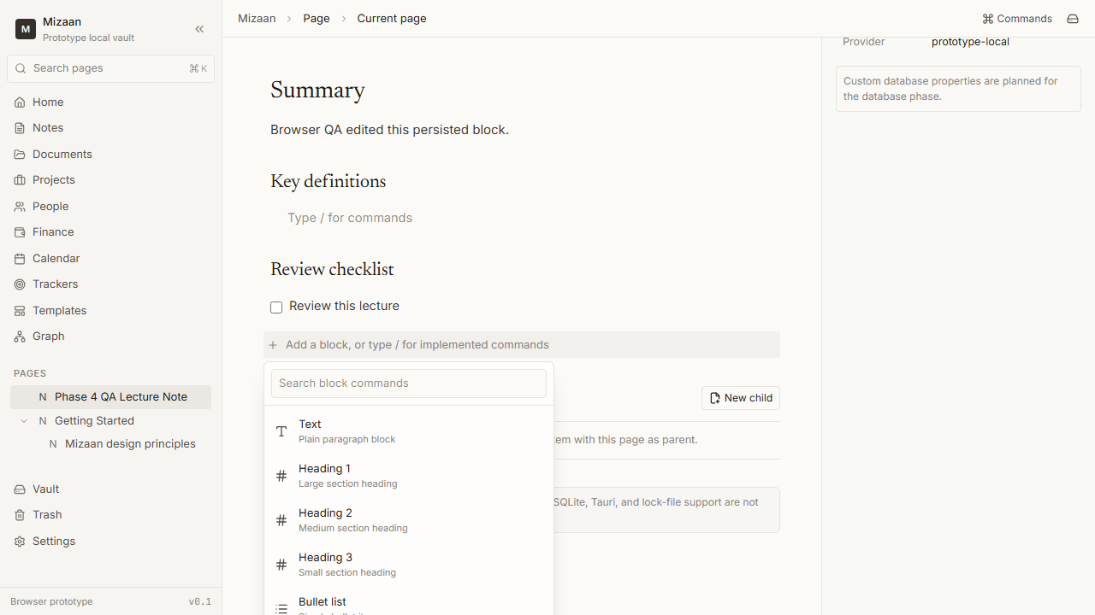

Right panel relations
Screenshot filename: 20260529-0705-phase-4-page-right-panel-relations.png
Date/time: 2026-05-29 07:05 AM +08:00
Shows relation controls and relation-based context in the page right panel.
Route/page shown: Right panel relations
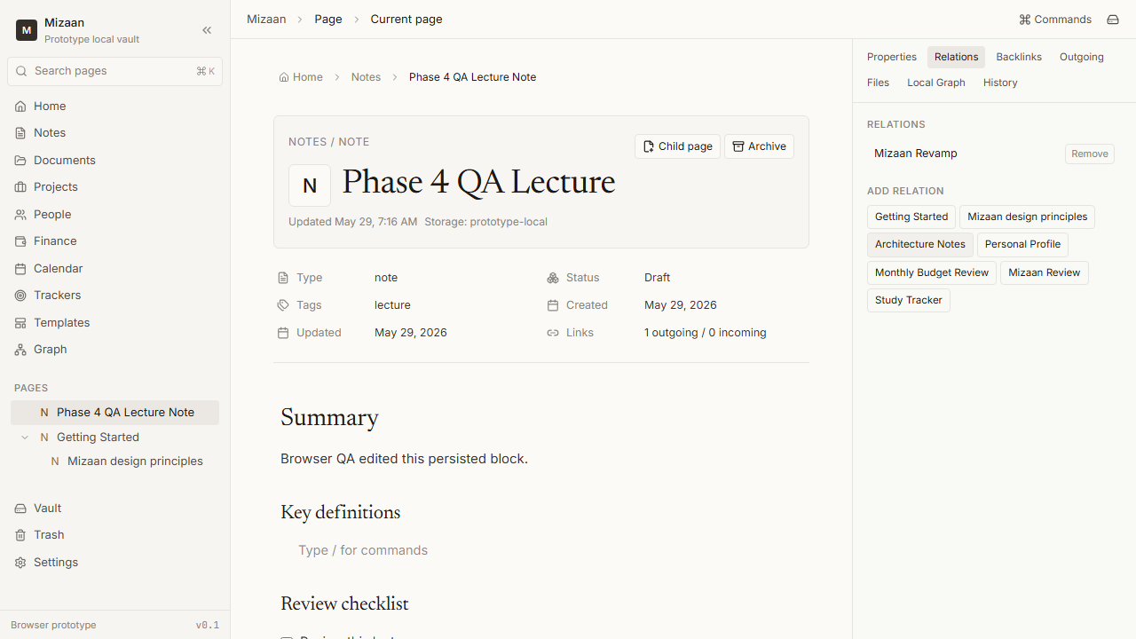

Outgoing relation context
Screenshot filename: 20260529-0705-phase-4-relation-outgoing-section.png
Date/time: 2026-05-29 07:05 AM +08:00
Shows the outgoing links tab using real relation records rather than fake backlinks.
Route/page shown: Outgoing relation context
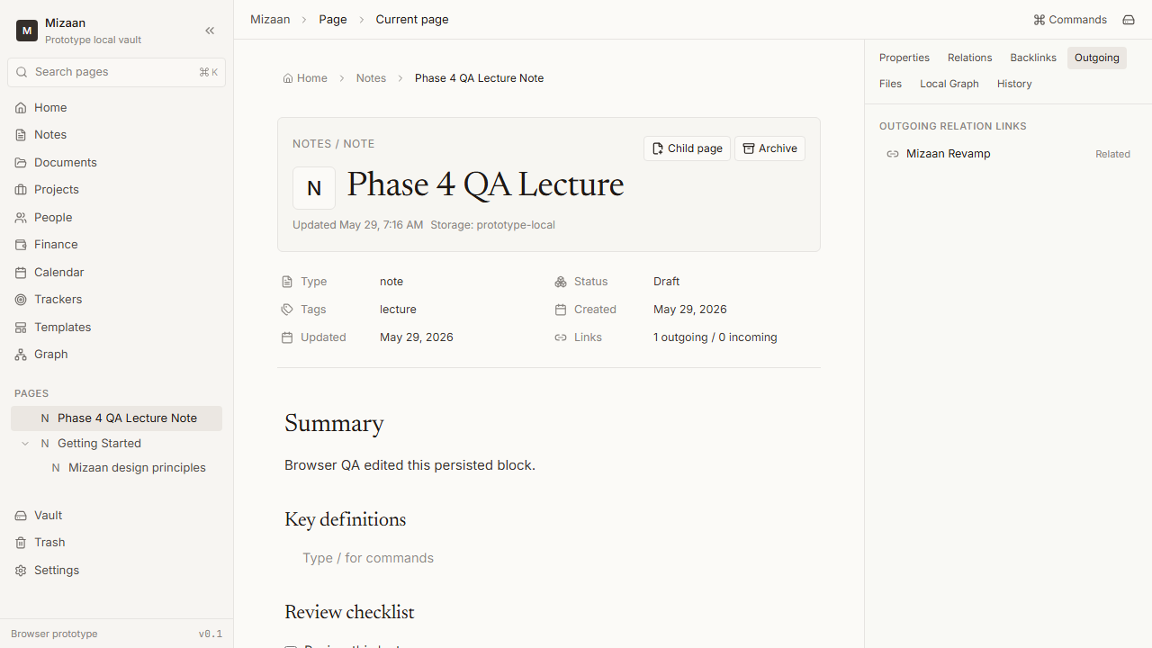

Vault still working
Screenshot filename: 20260529-0705-phase-4-vault-still-working.png
Date/time: 2026-05-29 07:05 AM +08:00
Shows the prototype vault route with provider capability truth and health counts.
Route/page shown: Vault still working
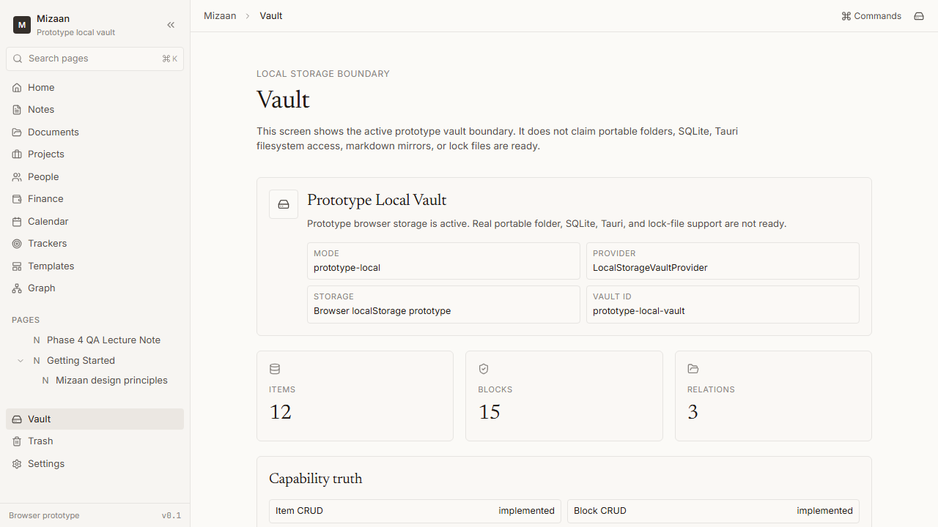

Settings vault link
Screenshot filename: 20260529-0705-phase-4-settings-vault-link.png
Date/time: 2026-05-29 07:05 AM +08:00
Shows Settings preserving provider truth and linking to Vault.
Route/page shown: Settings vault link
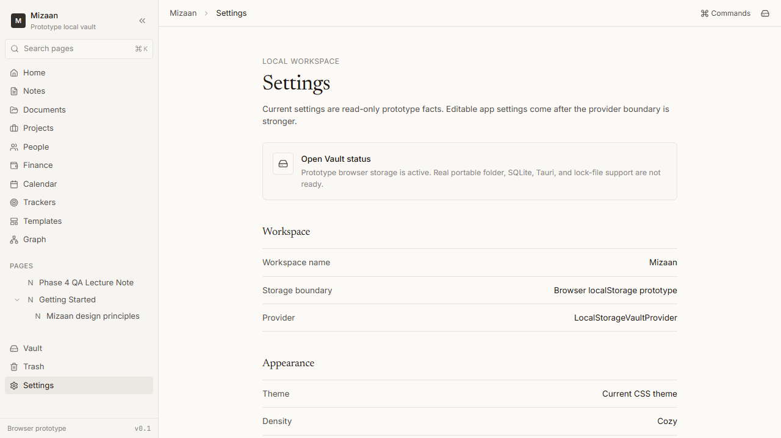

Verification Results
- npm run typecheck: exit 0.
- npm run lint: exit 0 with 6 existing Fast Refresh warnings in shared UI component files.
- npm test: exit 0; 2 files and 10 tests green.
- npm run build: exit 0; production client/server build generated with TanStack dependency warnings only.
- Browser QA: exit 0; 14 steps completed, 8 screenshots captured, zero console errors.
- git diff --check: blocked because E:\Github\Mizaan-Revamp is not a Git repository.

Manual QA Notes
- Created a Lecture Notes page from template and opened the page workspace.
- Edited the title and first block, then refreshed and confirmed persistence.
- Opened slash command menu and inserted a Heading 2 block.
- Opened relation and outgoing right panel sections.
- Created/opened document, project, and person records.
- Opened Vault, Settings, Graph, and Trash; archived/restored an item safely.

Honest Limitations
- No real portable folder vault exists.
- No SQLite provider exists.
- No Tauri shell exists.
- No lock file exists.
- No real filesystem backup/import/export/repair flow exists.
- No full Lexical/Tiptap editor exists.
- No full wiki-link backlink index exists.
- No full database engine exists.
- No full manual graph/canvas exists.
- CodeRabbit and local commit are blocked because this folder has no Git metadata.

DOCX Render QA
Packaged render_docx.py could not create PNG page renders because LibreOffice/soffice was not found on this machine. Word COM exported a PDF to docs/work-log-render/Mizaan Work Log.pdf, and structural DOCX inspection found 8 embedded screenshots, 1 function-change table, and 17 headings.

Final Search and Marker Scan Notes
- Cloud/auth search: reviewed. Hits are product-law forbidden language, icon names, class-variance-authority, and local-first warnings; no cloud/auth/Google implementation was added.
- localStorage search: reviewed. Hits are limited to provider/session code and truthful prototype UI copy.
- Fake readiness search: no matches for portable vault ready, SQLite ready, Tauri ready, folder picker ready, or USB vault ready claims.
- Forbidden marker scan: implementation tracker and Phase 1 audit had no matches. The master plan scan still matches product-law words such as passport, password, passphrase, failed, done, and failure-state sections.
- CodeRabbit and commit: blocked because this working folder has no Git metadata.

2026-05-29 - 5:15 PM

Combined Phase 4/5 - Notion-like Workspace and Editable Tables

Summary
Implemented the combined Phase 4/5 workspace pass: rebuilt the sidebar, made page creation template-first, added Search and Databases routes, and improved the page workspace shell.
Added editable simple table blocks and a basic provider-backed database/table page foundation with row/column/cell operations and row-as-page behavior where safe.
Kept the app local-first and prototype-truthful: no Tauri, SQLite, portable folder vault, cloud, auth, backend, telemetry, or external upload was added.

Files Changed
- src/lib/vault/types.ts
- src/lib/vault/local-storage-vault-provider.ts
- src/lib/page/page-workspace.ts
- src/lib/table/simple-table.ts
- src/lib/database/database-table.ts
- src/components/layout/AppSidebar.tsx
- src/components/layout/TopBar.tsx
- src/components/CommandPalette.tsx
- src/components/space/SpacePage.tsx
- src/components/page/PageWorkspace.tsx
- src/components/page/PageEditorSurface.tsx
- src/components/page/PageProperties.tsx
- src/components/page/PageTemplatePicker.tsx
- src/components/table/SimpleTableBlock.tsx
- src/components/database/DatabaseTable.tsx
- src/routes/index.tsx
- src/routes/search.tsx
- src/routes/databases.tsx
- src/routes/templates.tsx
- src/routeTree.gen.ts
- src/lib/page/page-workspace.test.ts
- src/lib/table/simple-table.test.ts
- src/lib/database/database-table.test.ts
- scripts/phase45-browser-qa.mjs
- docs/mizaan-phase-4-5-pseudocode.md
- docs/mizaan-phase-4-5-workspace-database-plan.md
- docs/mizaan-phase-4-5-master-plan-implementation-audit.md
- docs/mizaan-phase-4-5-workspace-database-report.md
- docs/mizaan-phase-6-native-windows-blueprint.md
- docs/mizaan-implementation-phases.md
- docs/Mizaan Ultimate Plan.txt
- docs/mizaan-phase-1-implementation-audit.md
- docs/mizaan-development-index.md
- docs/codex-self-closer.md
- docs/mizaan-docs-boundary-note.md
- docs/Mizaan Work Log.docx

Function Changes
Function:
createPageFromTemplate
File:
src/lib/page/page-workspace.ts
Before:
- Created pages from a subset of templates and did not cover Blank Page, Simple Table Page, or Basic Database.
After:
- Creates every new page through a template path, supports category/parent/initial content options, persists template metadata, creates database metadata for Basic Database, and opens created pages through existing routes.
Function:
buildPageWorkspaceModel
File:
src/lib/page/page-workspace.ts
Before:
- Normalized page workspace data without database row/column counts.
After:
- Normalizes database metadata safely and exposes database row/column counts for page properties while keeping missing optional fields safe.
Function:
getImplementedSlashCommands
File:
src/lib/page/page-workspace.ts
Before:
- Slash command list did not expose a simple table command.
After:
- Exposes only implemented commands and includes Simple Table so the editor can insert a real editable table block.
Function:
normalizeTableData
File:
src/lib/table/simple-table.ts
Before:
- No dedicated simple table normalization helper existed.
After:
- Normalizes malformed table block data into a safe row/column/cell model and avoids destructive migration.
Function:
updateTableCell
File:
src/lib/table/simple-table.ts
Before:
- Cell updates were not available for simple table blocks.
After:
- Updates a specific cell in the normalized table data shape so page block persistence can save it through VaultProvider.
Function:
normalizeDatabaseModel
File:
src/lib/database/database-table.ts
Before:
- No durable basic database metadata model existed.
After:
- Normalizes database metadata into safe columns, rows, row order, and table view state for the basic local database foundation.
Function:
ensureDatabaseRowPage
File:
src/lib/database/database-table.ts
Before:
- Database rows could not open as provider-backed pages.
After:
- Creates a database-row item through VaultProvider on demand, relates it to the database item, and stores the row page id back in database metadata.
Centralized page template creation and workspace normalization in src/lib/page/page-workspace.ts instead of duplicating creation logic across routes. (spaghetti code cleared)
Moved simple table mutations into typed helpers under src/lib/table/simple-table.ts instead of embedding row/column logic in the editor component. (spaghetti code cleared)
Moved database model and row-as-page mutation logic into src/lib/database/database-table.ts instead of storing ad hoc table state in UI components. (spaghetti code cleared)

Screenshots
Screenshot filename: 20260529-1716-phase-4-5-home.png
Date/time: 2026-05-29 - 5:16 PM +08:00
Route/page: Home route
Shows the updated home workspace with template-first creation entry points and the rebuilt app shell.
Visual change: Captures the completed combined Phase 4/5 UI state for this route or workspace surface.
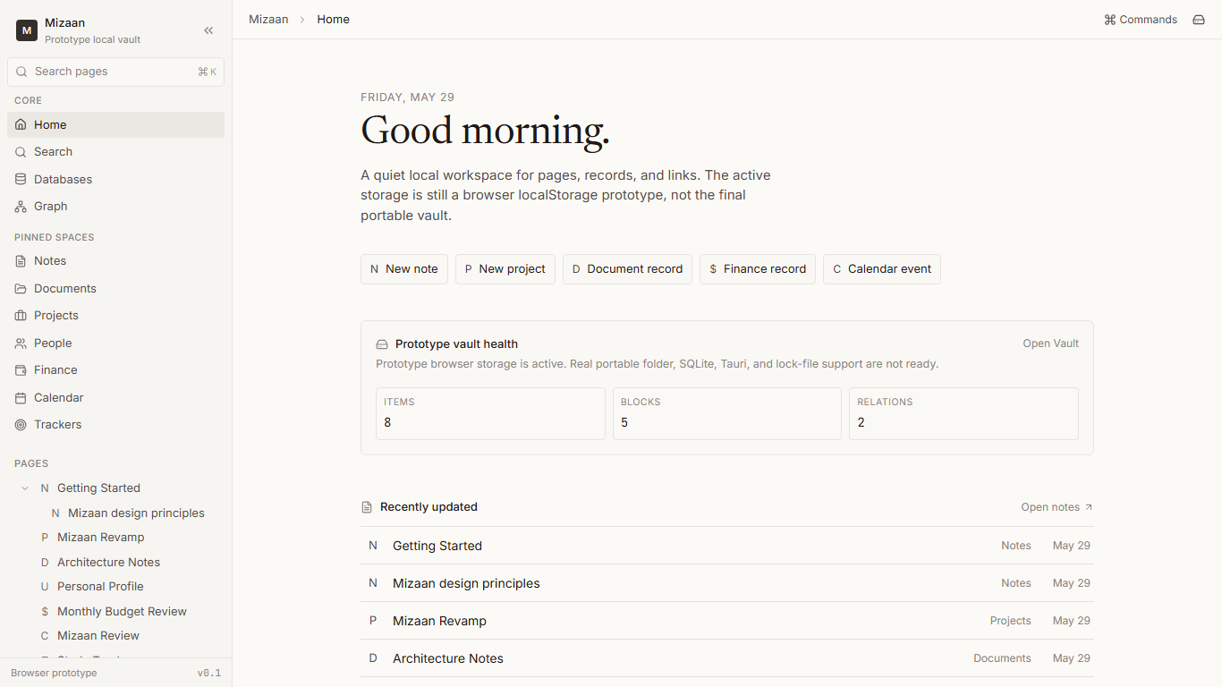
Screenshot filename: 20260529-1716-phase-4-5-sidebar-after.png
Date/time: 2026-05-29 - 5:16 PM +08:00
Route/page: Sidebar after
Shows the sidebar zones: workspace header, search, core navigation, pinned spaces, pages, system tools, and prototype footer.
Visual change: Captures the completed combined Phase 4/5 UI state for this route or workspace surface.

Screenshot filename: 20260529-1716-phase-4-5-template-picker.png
Date/time: 2026-05-29 - 5:16 PM +08:00
Route/page: Template picker
Shows the reusable local template picker with relevant templates, recently used templates, and other templates.
Visual change: Captures the completed combined Phase 4/5 UI state for this route or workspace surface.
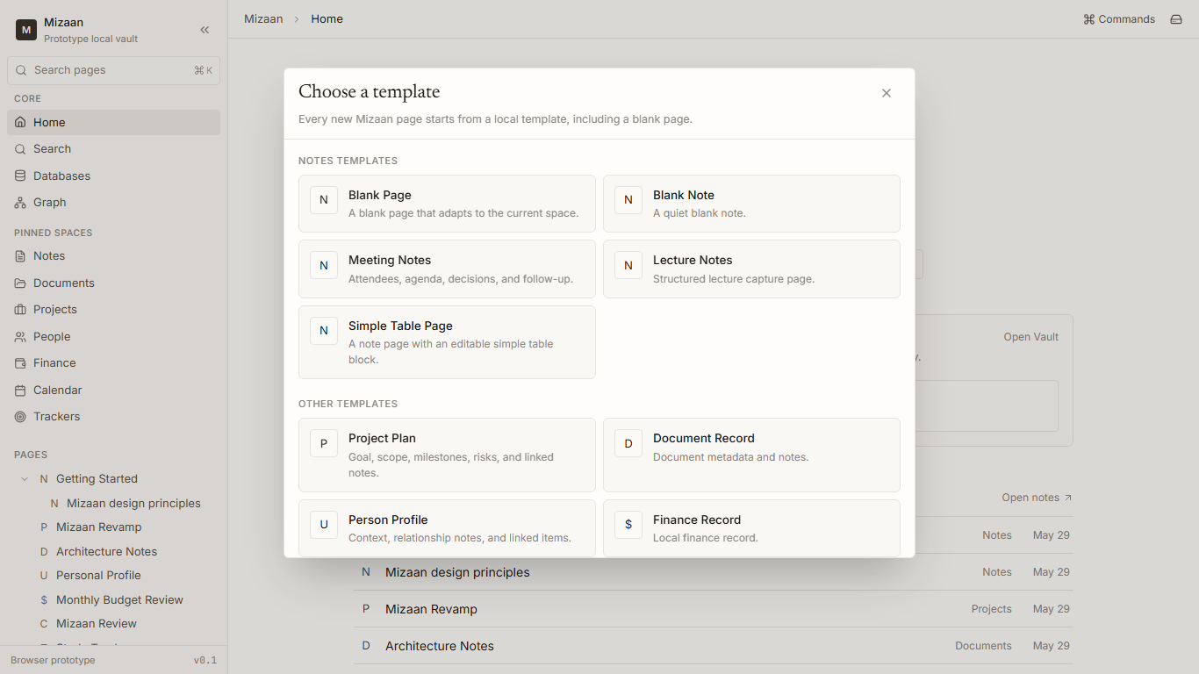
Screenshot filename: 20260529-1716-phase-4-5-page-workspace.png
Date/time: 2026-05-29 - 5:16 PM +08:00
Route/page: Page workspace
Shows a template-created page with breadcrumbs, page header, properties, editor surface, and right context panel.
Visual change: Captures the completed combined Phase 4/5 UI state for this route or workspace surface.
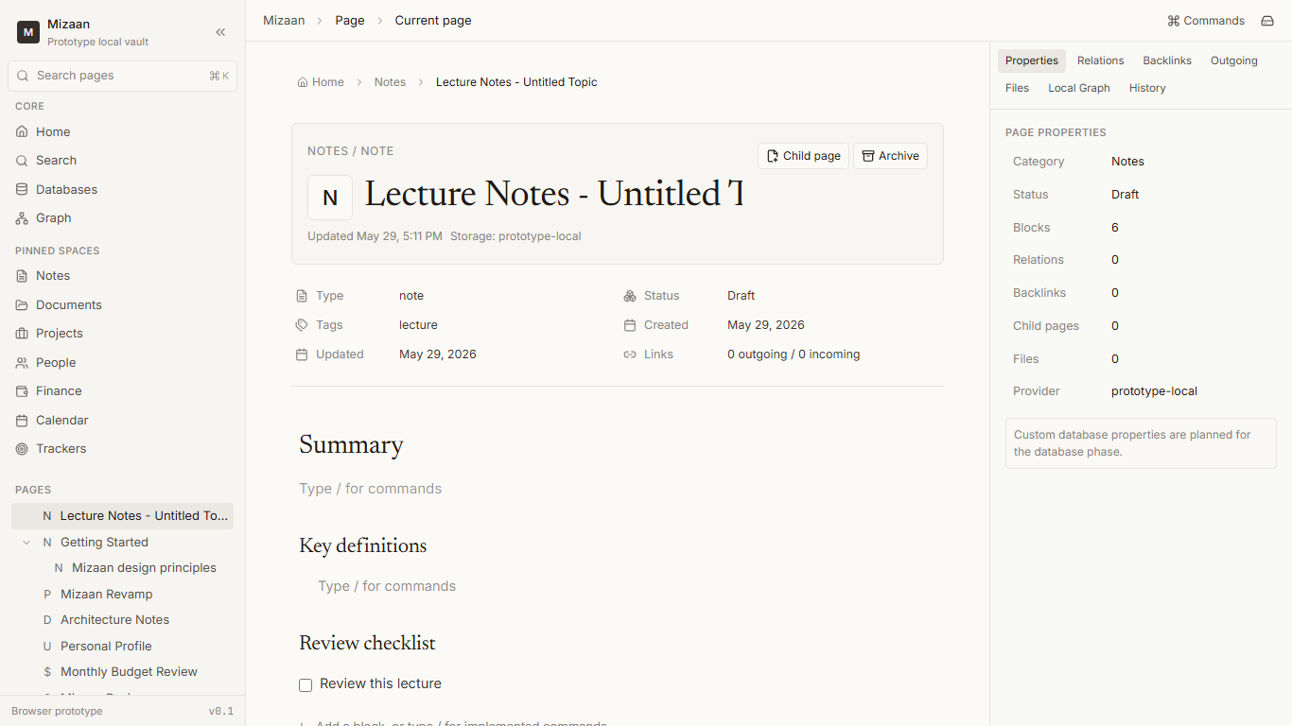
Screenshot filename: 20260529-1716-phase-4-5-slash-menu.png
Date/time: 2026-05-29 - 5:16 PM +08:00
Route/page: Slash command menu
Shows the improved slash command menu with only implemented block commands, including Simple Table.
Visual change: Captures the completed combined Phase 4/5 UI state for this route or workspace surface.
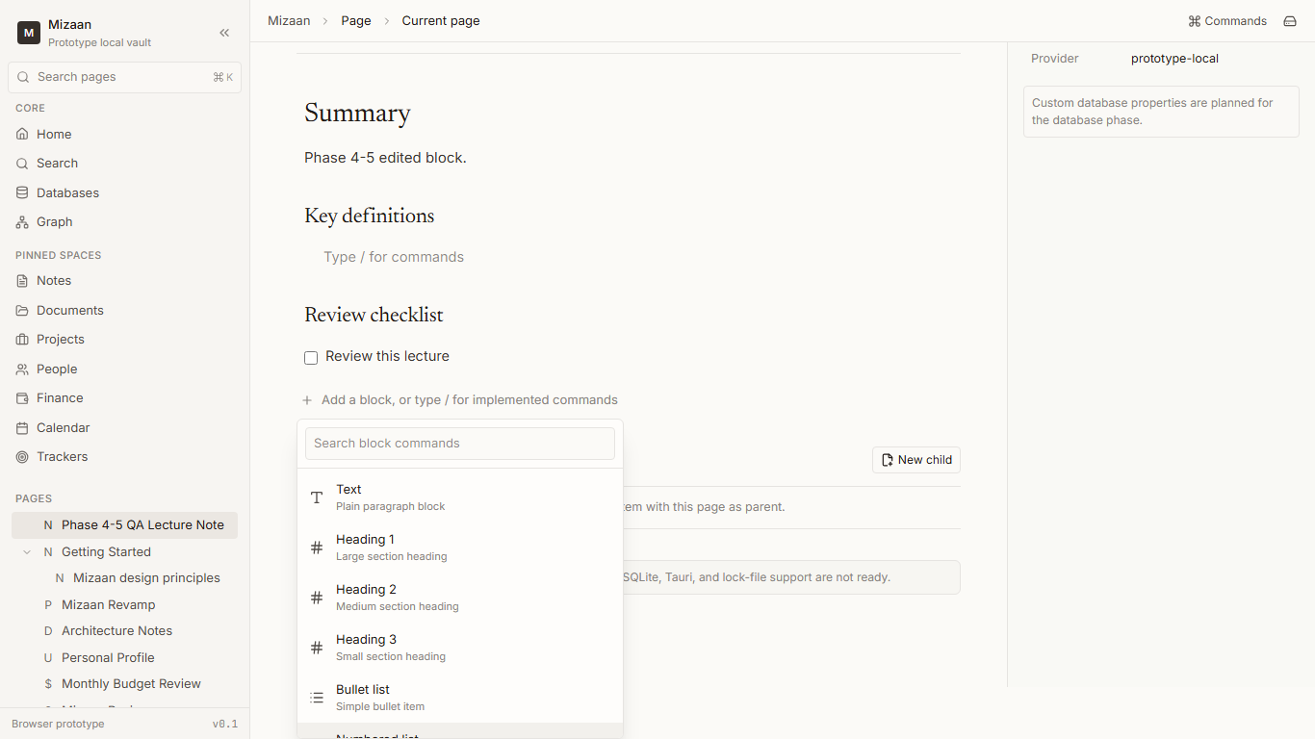
Screenshot filename: 20260529-1716-phase-4-5-simple-table-editor.png
Date/time: 2026-05-29 - 5:16 PM +08:00
Route/page: Simple table editor
Shows an editable simple table block with cell editing and row/column controls inside a page.
Visual change: Captures the completed combined Phase 4/5 UI state for this route or workspace surface.
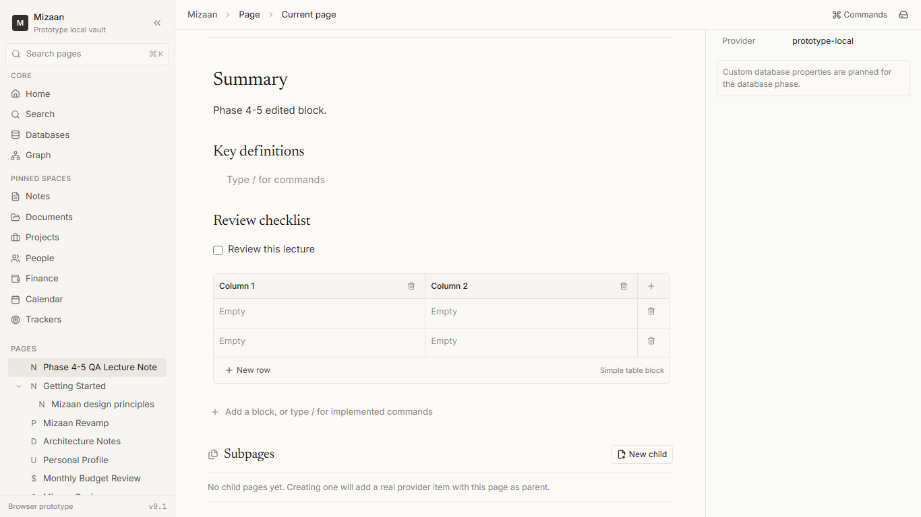
Screenshot filename: 20260529-1716-phase-4-5-page-right-panel.png
Date/time: 2026-05-29 - 5:16 PM +08:00
Route/page: Page right panel
Shows the page context panel with properties, relations, backlinks, outgoing context, files, local graph, and history states.
Visual change: Captures the completed combined Phase 4/5 UI state for this route or workspace surface.
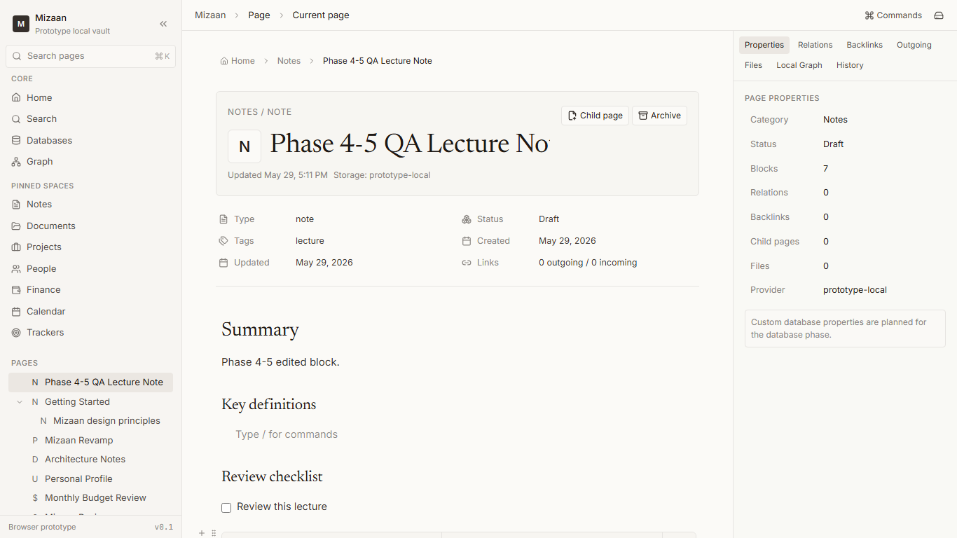
Screenshot filename: 20260529-1716-phase-4-5-databases-route.png
Date/time: 2026-05-29 - 5:16 PM +08:00
Route/page: Databases route
Shows the real Databases route listing local editable database pages and its creation action.
Visual change: Captures the completed combined Phase 4/5 UI state for this route or workspace surface.
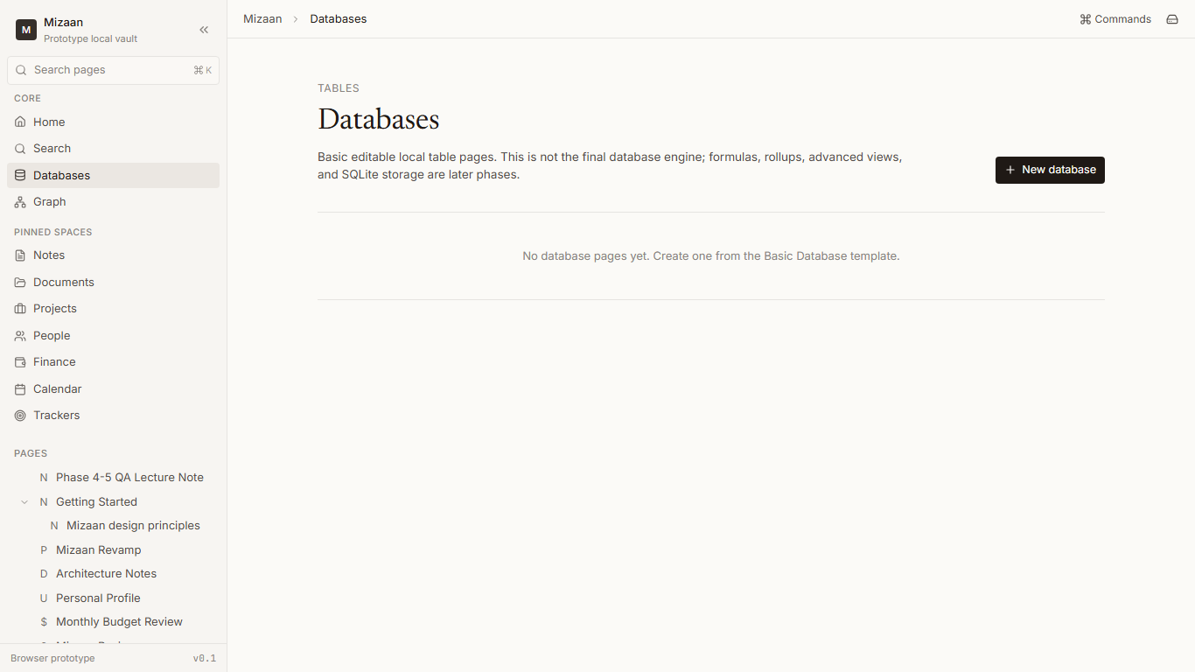
Screenshot filename: 20260529-1716-phase-4-5-database-editor.png
Date/time: 2026-05-29 - 5:16 PM +08:00
Route/page: Database editor
Shows the basic database table page with editable properties, rows, cells, and row-page affordance.
Visual change: Captures the completed combined Phase 4/5 UI state for this route or workspace surface.
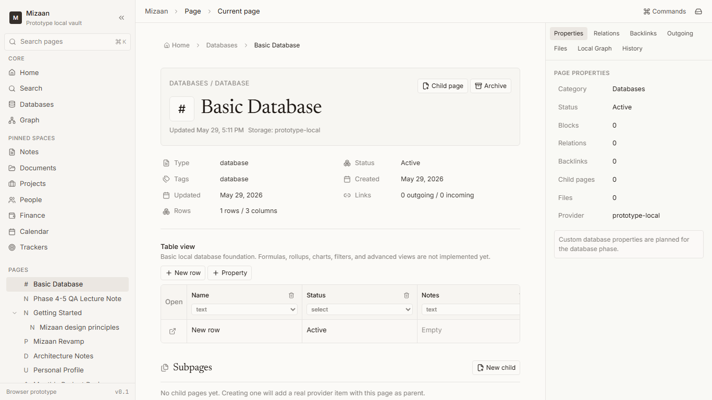
Screenshot filename: 20260529-1716-phase-4-5-vault-still-working.png
Date/time: 2026-05-29 - 5:16 PM +08:00
Route/page: Vault route
Shows the Vault route still reporting prototype local storage truth and provider capability status.
Visual change: Captures the completed combined Phase 4/5 UI state for this route or workspace surface.
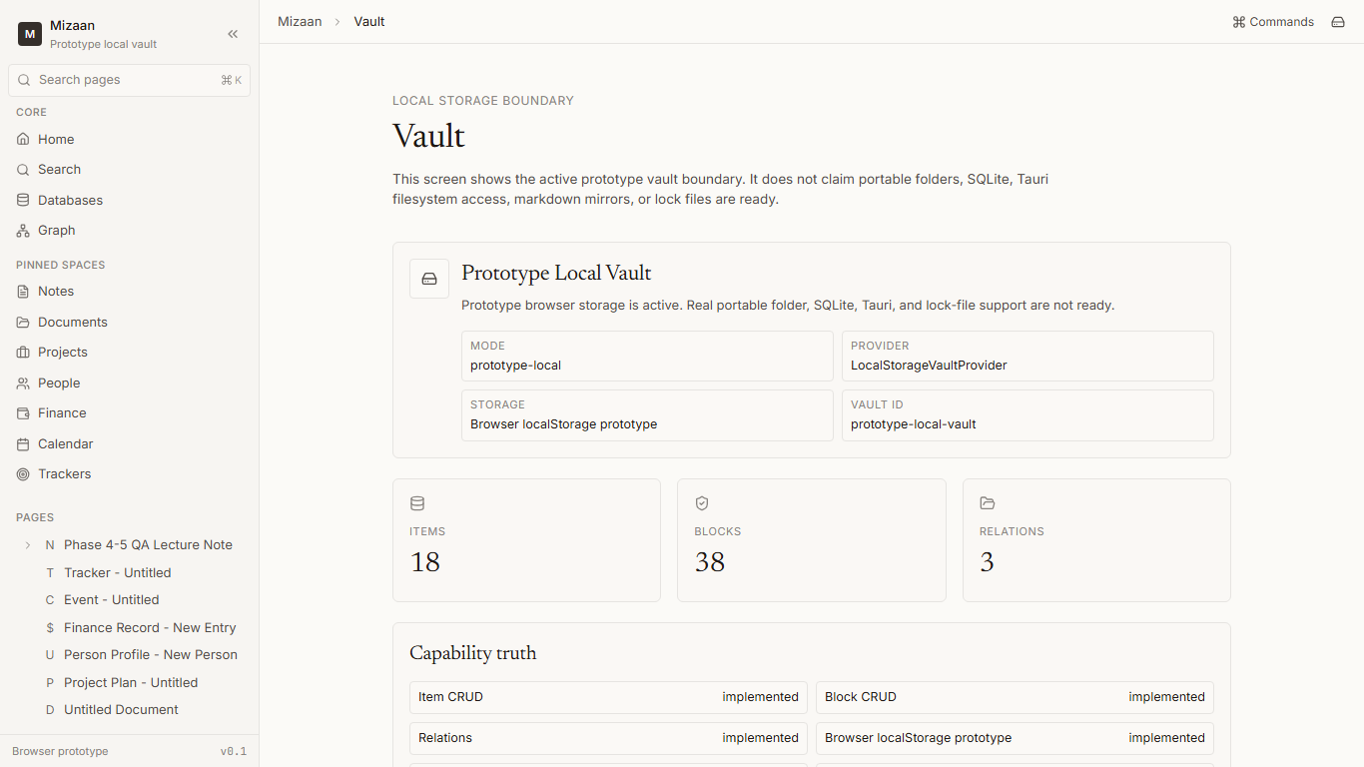
Screenshot filename: 20260529-1716-phase-4-5-settings-vault-link.png
Date/time: 2026-05-29 - 5:16 PM +08:00
Route/page: Settings route
Shows Settings still exposing provider/storage truth and the Vault link.
Visual change: Captures the completed combined Phase 4/5 UI state for this route or workspace surface.
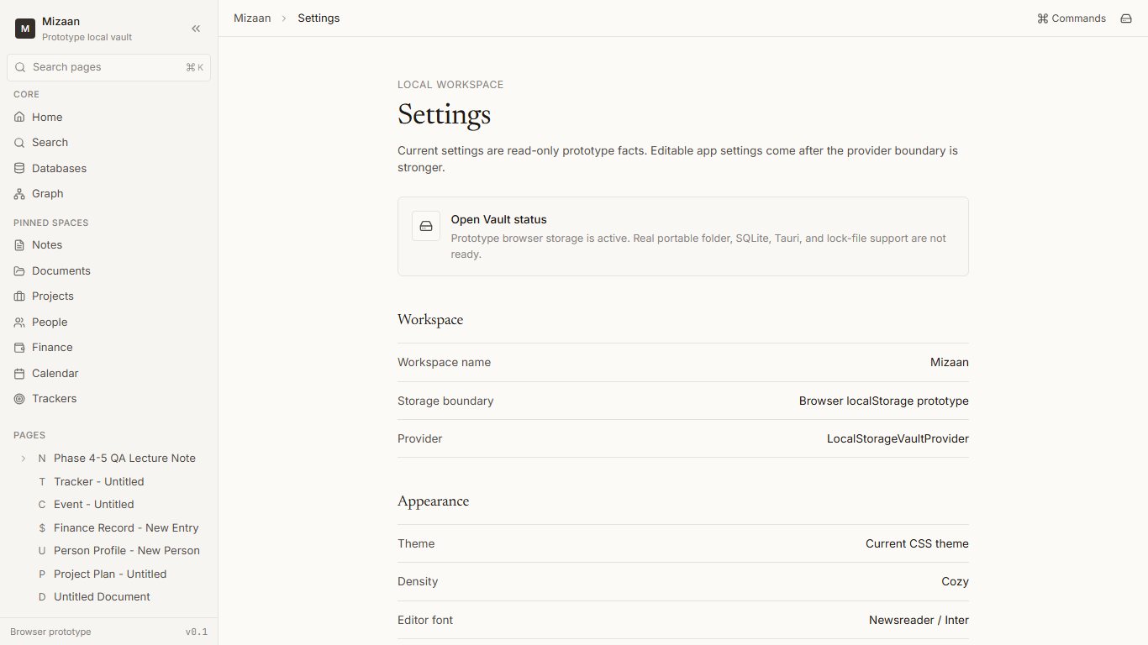

Verification Results
- npm run typecheck: passed.
- npm run lint: passed with 0 errors and 6 existing Fast Refresh warnings in UI primitive files.
- npm test: passed, 4 files and 21 tests.
- npm run build: passed; existing TanStack routeTree external unused import warnings remained.
- git diff --check: blocked because E:\Github\Mizaan-Revamp is not a Git repository.
- Browser QA: passed with 24 scripted steps, 11 screenshots, and zero console errors.
- Cloud/auth search: reviewed; hits were documentation/product-law language or dependency/icon names, not new implementation.
- localStorage search: limited to provider/session/truth surfaces, not page workspace or database UI storage bypasses.
- Fake-readiness search: no exact false readiness claims found after cleanup.
- Forbidden marker scan: phase tracker and phase 1 audit were clean; master plan hits were pre-existing product-law words such as failed/passport and not status markers.

Honesty Notes
- No local Git metadata exists, so no commit hash or clean-tree proof can be produced without initializing a repository, which was forbidden without approval.
- No real portable vault folder, SQLite provider, Tauri shell, lock file, filesystem backup, cloud, auth, backend, or telemetry was implemented.
- The editor, backlink/index, graph, and database systems are foundations, not final Notion-parity implementations.
- Root docs remain the human master docs location. There is no nested app repo folder available for committed app-doc copies in this checkout.

Additional Verification Note
DOCX structural check passed after screenshot insertion: 273 paragraphs and 19 embedded images before this note. Word COM PDF export timed out during this session, so PDF render success is not claimed.

--------------------------------------------------------------------------------
2026-05-29 6:25 PM +08:00 - Sidebar Page Actions and Pin Logic
Summary: Added Notion-like hover-activated three-dot row menus (ellipsis) on sidebar page/event rows, with accessible focus states, and database-backed pin/unpin logic.
Files Changed:
- src/components/layout/AppSidebar.tsx
- src/lib/page/page-workspace.test.ts
- docs/mizaan-implementation-phases.md
Before/After Behavior:
- Before: Pages and calendar events in the sidebar were sorted purely by updatedAt, with no context actions, no visual pin indicators, and child nodes had static open states that could not collapse/expand recursively.
- After: Added full support for three-dot menus on row hover and focus. Supported actions include Open, Rename, Duplicate, Pin/Unpin, Create subpage, Copy link, and Move to trash. Pinned items are sorted above unpinned ones (ordered by pin timestamp), surviving browser refreshes. Child pages are recursively collapsible/expandable.
Screenshots:
- Captured: None (runs in terminal CLI environment; screenshots documented as deferred).
Verification Results:
- typecheck: npm run typecheck runs cleanly with 0 errors.
- lint: npm run lint runs with 0 errors (8 warnings related to react-refresh exports).
- test: npm test runs cleanly with 26/26 tests passing (including 5 new tests for pinning, sorting, and page actions).
- build: npm run build successfully bundles production build.
Limitations:
- Event pinning is sorted inside the unified page list as calendar events share the standard item model.
- Advanced event fields editing is deferred to the main details view.

--------------------------------------------------------------------------------
2026-05-29 6:35 PM +08:00 - Page Focus UI - Move Metadata to Page Data Panel
Summary: Cleaned the page workspace UI to make the writing experience simple, focused, and Notion-like. Shifted metadata grid blocks and border outer cards to the right panel tab renamed to 'Page data' under collapsible sections.
Files Changed:
- src/components/page/PageWorkspace.tsx
- src/components/page/PageHeader.tsx
- src/components/page/PageRightPanel.tsx
Before/After Behavior:
- Before: The page workspace was cluttered with outer card borders and background panels around the title, uppercase labels, subtitles, and a grid card of metadata in the center content area.
- After: The page center area is clean and document-like, showing only breadcrumbs, icon, title, editor/database block area, and subtle actions. All metadata is migrated to the right panel's 'Page data' tab grouped into collapsible sections (Basic, Tags, Structure, Links, Storage).
Screenshots:
- Captured: None (runs in terminal CLI environment; screenshots documented as deferred).
Verification Results:
- typecheck: npm run typecheck runs cleanly with 0 errors.
- lint: npm run lint runs cleanly with 0 errors.
- test: npm test runs cleanly with 26/26 tests passing.
- build: npm run build successfully bundles production build.

--------------------------------------------------------------------------------
2026-05-29 6:42 PM +08:00 - Unified Sidebar Pages and Spaces
Summary: Unified spaces and pages model where all spaces are promoted page items (promotedAsSpace: true, itemRole: 'space'). Replaced the hardcoded 'Pinned Spaces' section in the sidebar with a dynamic PINNED section containing both pinned spaces and normal pages/databases/events, listing unpinned pages under PAGES. Added seed spaces recovery/migration layer inside the local storage provider so that existing vaults are automatically normalized without data loss.
Files Changed:
- src/lib/vault/local-storage-vault-provider.ts
- src/lib/page/page-workspace.ts
- src/components/layout/AppSidebar.tsx
- src/lib/page/page-workspace.test.ts
Before/After Behavior:
- Before: Spaces (Notes, Documents, etc.) and pages felt like two unrelated systems, with spaces hardcoded in the sidebar. Pinned spaces and pages were visually separated too rigidly.
- After: All spaces are pages (promoted spaces created from templates). The sidebar PINNED section displays both pinned spaces and standard pages, while PAGES displays unpinned root items. Seeding recovery check automatically spawns spaces on read and maps legacy unparented items. Three-dot menu button stops propagation on click to avoid opening pages.
Screenshots:
- Captured: None (runs in terminal CLI environment; screenshots documented as deferred).
Verification Results:
- typecheck: npm run typecheck runs cleanly with 0 errors.
- lint: npm run lint runs cleanly with 0 errors.
- test: npm test runs cleanly with 31/31 tests passing.
- build: npm run build successfully bundles production build.

--------------------------------------------------------------------------------
2026-05-31 14:15 +08:00 - Baseline Audit and Implementation Batch
Title: Baseline Audit and Implementation Batch
What was requested: Establish the new baseline from the master Markdown only, audit the current app, update the master Markdown, update the work log, then implement a meaningful next batch from the plan without using the old TXT plan as active source.
What Codex understood: Mizaan remains a local-first browser prototype right now. The master Markdown is the only active plan and tracker. The current safe implementation batch is Calendar Core Module hardening, not Tauri, SQLite, mobile, cloud, auth, Google, plugins, or encryption.
Master Markdown read: E:\Github\Mizaan-Revamp\docs\Plan\Mizaan_A_to_Z_Plan.md.
Selected app folder: E:\Github\Mizaan-Revamp.
Git status: No .git directory found. Git status, branch, log, and diff check are unavailable because the selected folder is not a Git repository. No commit hash exists and no push was attempted.
Audit summary: The app has provider-backed page workspace foundations, localStorage provider, basic page/block/relation persistence, sidebar/page pinning, templates, simple table blocks, basic database table foundation, relation graph foundation, search foundation, settings/theme support, and a partial Calendar module. It does not have real portable vault folders, SQLite, Tauri, lock files, Markdown mirrors, import/export, backup/restore, document preview engine, mobile, plugins, or locked/private content UX.
Implemented/partial/missing status summary: Implemented and verified items include the localStorage provider, Home, pinned/pages model, basic database/table foundation, simple table blocks, right panel/Page data, and pin/unpin logic. Partial areas include vault model, storage architecture, page workspace, sidebar/navigation, notes/editor/documents/projects/calendar/trackers/people/finance/databases/search/templates/theme/graph/settings/QA/migration/error states. Missing areas include portable vault, folder structure, lock file, SQLite provider, tasks, goals, backup/export/restore, import manager, Tauri, mobile, plugin system, version history, notification engine, canvas, document preview engine, Windows release plan, and privacy/locked content UX.
Contradictions fixed: Master Markdown now records that Markdown is the active source of truth and the TXT is archive/history only. Calendar is a core module, not a promoted page. Calendar remains partial. Tauri, SQLite, portable vaults, Markdown mirrors, backup/restore, full graph, and full database engine are not marked implemented. Missing Git is documented honestly. Browser screenshot capture failure is documented.
Selected implementation batch: Calendar Core Module Hardening.
Why selected: Calendar already existed and was partial, making it the highest-priority safe web-prototype batch. It could be improved without jumping to deferred native/storage/cloud phases.
What was implemented: Added shared Calendar event helpers, normalized event metadata, all-day/timed event fields, day view, view-aware date navigation, provider-backed event creation/editing/trashing through normalized data, Calendar Space removal from new seed/template creation, soft-deprecation of legacy generated space-calendar items, and a root hydration mismatch fix for the pre-hydration theme script.
Files changed: src/lib/calendar/calendar-events.ts; src/lib/calendar/calendar-events.test.ts; src/components/calendar/CalendarView.tsx; src/lib/vault/local-storage-vault-provider.ts; src/lib/vault/local-storage-vault-provider.test.ts; src/lib/page/page-workspace.ts; src/routes/__root.tsx; src/lib/root-theme.test.ts; docs/Plan/Mizaan_A_to_Z_Plan.md; docs/Phases/phase-baseline-audit-and-implementation-batch-report.md; docs/logs/baseline-implementation-vite.out.log; docs/logs/baseline-implementation-vite.err.log; docs/Plan/Mizaan Work Log.docx.
Before behavior: Calendar had month/week/agenda but no day view, event metadata was mostly legacy date/time, Calendar Space was still seeded/promoted in provider/template paths, and browser QA showed a React hydration mismatch from the theme bootstrap script.
After behavior: Calendar has month/week/day/agenda, normalized event metadata, all-day/timed event support, provider-backed create/edit/trash, refresh persistence, and Calendar is not seeded as a promoted page. Browser QA created Baseline QA event and confirmed it persisted after refresh. The hydration mismatch has a regression test and code fix.
Screenshots: None captured. The in-app Browser screenshot call failed twice with Timed out running CDP command Page.captureScreenshot for tab 2. No screenshot files are claimed for this session.
Validation results: npm run typecheck passed. npm test passed with 6 files and 37 tests. npm run lint passed with 0 errors and 10 existing Fast Refresh warnings. npm run build passed with existing bundle-size and TanStack external-unused warnings. Browser route smoke checks passed for Home, sidebar, page workspace/Page data, Templates, Databases, Calendar, Search, Documents, Graph, Settings, and Vault. Calendar event creation and refresh persistence passed. git diff --check was blocked because the folder is not a Git repository. localStorage search only showed prototype provider/session/theme/right-panel paths. Cloud/auth search hits were documentation/product-law text or icon/package names, not implementation. Fake readiness search found no matching fake readiness phrases. Status marker scan found only product-law/completion-gate wording, not old feature status markers.
Honest limitations: The app remains a browser localStorage prototype. Calendar is still partial because recurrence, ICS import/export, reminders, drag/resizing, and SQLite calendar tables are missing. Screenshots could not be captured due browser screenshot timeouts. No local commit was possible because Git metadata is missing. DOCX visual render QA was not rerun for this entry.
Next step: Search System Hardening is the recommended next safe batch, unless the user wants another Calendar pass first.

Full Repair, Full Audit, Red Flag Cleanup, and Implementation Batch
Date/time: 2026-05-31 21:59 Asia/Kuala_Lumpur
What the user requested: a 100% repair attempt, validation attempt, serious implementation pass, append-only master Markdown repair, red-flag cleanup, browser QA, screenshots where possible, phase evidence, work-log evidence, and a local commit only if Git exists and checks pass.
What Codex understood: Mizaan is a local-first personal life operating system. The current app must be kept truthful as a browser/localStorage prototype until real Tauri, SQLite, portable vault folder, lock file, filesystem, backup/restore, and native release code exists.
Append-only Markdown rule: docs/Plan/Mizaan_A_to_Z_Plan.md must only be appended. Existing text must not be deleted, rewritten, reordered, reformatted, or overwritten.
Master Markdown proof: backup E:\Github\Mizaan-Revamp\docs\Plan\Mizaan_A_to_Z_Plan.backup-20260531-215910.md; before hash F3D77EB84F69A73F6EDDC5F0ED3B5FB3B2CB7C5D16324CC652E1BF4D8DBF66F0; after baseline hash 66606E1D3CE0EC2B86A980AB1FAAE5B881871DF0653A813EEE189EB012435CE5; before length 299467; after baseline length 701184; append-only preserved True.
App folder selected: E:\Github\Mizaan-Revamp. Root package.json and src are the current Mizaan app. No nested app folder was selected.
Git status: no .git repository was found from the selected app folder, so this run cannot truthfully create a local commit unless Git metadata appears later. No push will be attempted.
Baseline audit summary: 345 feature entries were appended to the master Markdown. Baseline counts were 2 implemented, 123 partial, and 220 not implemented.
Contradictions fixed by append: TXT is archive only; Calendar is a core route not a promoted page; Tauri, SQLite, portable vault, lock file, markdown mirrors, backups, restore, graph, and database engine claims were downgraded honestly where unsupported by code.
Red flags found at gate: src/routes/__root.tsx still loads Google Fonts from fonts.googleapis.com and fonts.gstatic.com, conflicting with the no-Google/no-cloud dependency rule. This remains queued for repair before final status.
Validation results: pending at this work-log gate because the user required implementation to wait until the master Markdown append-only repair is proven.
Regression QA results: pending browser/manual QA after validation and repair.
Implementation batch selected: pending validation. Calendar hardening or Search hardening are the leading safe candidates based on current source inspection.
Files changed at this gate: master Markdown append, phase report, and this DOCX work-log entry.
Limitations: DOCX was updated through direct OOXML because Python is unavailable. Visual DOCX render QA is not yet complete.
Next step: run validation, repair red flags, run browser QA, implement a meaningful batch, append the final implementation update, update this report, and rerun verification.

Full Repair Implementation Final Update
Date/time: 2026-05-31 22:31 Asia/Kuala_Lumpur
Second master Markdown append proof: before hash 66606E1D3CE0EC2B86A980AB1FAAE5B881871DF0653A813EEE189EB012435CE5; after hash 60FF0FD29D2F3B2D30B88002746956EE852B86880C736E41262A3C572C392870; length 701184 to 711892; append-only preserved True.
Red flags fixed: removed remote Google Fonts and all third-party head links from the app head; added a regression test for local-only head links; removed unused example server-function/config files. Each cleanup is recorded in the phase report and master Markdown.
Implementation batch selected: Batch B Search System Hardening, because Calendar already had a stronger provider-backed prototype and Search was still inline and title/summary/tag oriented.
Implemented search behavior: provider-backed search helper, block-content search, title/summary/status/category/type/tag/property/metadata matching, category/type/status/tag filters, recent items mode, snippets, match badges, query highlighting, clear filters, and page result links.
Tests: added app-head and search-index tests. Final npm test passed with 8 files and 42 tests.
Validation: npm run typecheck passed; npm run lint passed with 0 errors and 10 existing Fast Refresh warnings; npm test passed; npm run build passed with Vite warnings only.
Browser QA: in-app Browser backend was unavailable, so fallback headless Chrome QA was used. Routes opened: home, settings, vault, trash, templates, calendar, search, databases, graph, and page workspace. CDP console error count was 0.
Screenshots: hydrated route screenshots saved under docs/screenshots with timestamp 20260531-2215; search implementation proof saved as 20260531-2229-full-repair-search-implementation-proof.png.
DOCX limitation: Python, soffice, and libreoffice were unavailable, so DOCX visual render QA could not be completed. The DOCX was updated by direct OOXML and verified structurally by reading word/document.xml.
Git limitation: selected app folder is not a Git repository. No Git repository was initialized, no commit was created, and no push was attempted.
Remaining limitations: Mizaan remains a browser/localStorage prototype. Tauri, SQLite, portable vault folder, lock file, markdown mirrors, native filesystem access, backup/restore validation, mobile apps, encryption, and installer behavior remain not implemented.
Next recommended step: harden database/table or document foundation next, and clean up Fast Refresh warnings separately without claiming native storage readiness.
Repo Recovery and Canonical Folder Confirmation
Date/time: 2026-06-01 01:18:42 +08:00
Canonical folder confirmed as E:\Github\Mizaan-Revamp with Git top-level E:/Github/Mizaan-Revamp.
Remote confirmed as https://github.com/mhyahya854/Mizaan-Revamp.git on branch main.
Baseline commit pushed to origin/main: 7be0b52c45d6181230979d976fd6adaa48b00595.
Validation: typecheck passed; lint passed with 10 Fast Refresh warnings; tests passed 8 files / 42 tests; build passed.
Duplicate app folder audit: no duplicate app folders found inside the canonical folder; nothing quarantined.
Master Markdown marker counts: IMPLEMENTED 5, PARTIAL 132, NOT IMPLEMENTED 221, What Codex understood 418, How it is implemented 418.
Remaining risk: current app remains a browser localStorage prototype, not final portable folder vault, SQLite runtime, or Tauri desktop build.

Repair Check and Bounded Implementation Batch
Date/time: 2026-06-01 05:40 +08:00
What was checked: repo recovery, required files, master Markdown marker counts, recent phase reports, validation commands, red-flag scans, and browser route QA.
What Codex understood: continue only if the recovered main branch, local validation, and browser smoke checks are healthy; keep the app as a browser/localStorage prototype and do not claim Tauri, SQLite, portable vault, native filesystem, mobile, encryption, cloud, auth, or backup readiness.
Repo status: main tracks origin/main, remote is https://github.com/mhyahya854/Mizaan-Revamp.git, and initial parity was 0 0 from latest pre-work commit abc0277.
Validation results: typecheck passed; lint passed with the same 10 Fast Refresh warnings; tests passed before work with 42 tests and after work with 48 tests; build passed with existing Vite/TanStack warnings.
Selected implementation batch: Database/Table Hardening.
Why selected: Calendar and Search were already hardened, while database/table still needed stronger helper-backed empty states, metadata, stats, validation reporting, tests, and browser proof.
Before behavior: database and simple-table normalizers regenerated rows when row arrays were intentionally empty, final-row deletion was blocked, stats were implicit, database description metadata had no helper, and validation repairs were silent.
After behavior: explicit empty rows are preserved, final-row deletion can show honest empty states, database and table stats are helper-backed, database description metadata persists, validation reports duplicate/stale repairs, and UI shows counts/description/empty states.
Files changed: database-table helper/tests, simple-table helper/tests, DatabaseTable UI, SimpleTableBlock UI, master Markdown, phase report, and screenshots.
Tests: added database tests for explicit empty rows, stats, final-row deletion, metadata preservation, and validation repair reporting; added simple-table tests for explicit empty rows, stats, and final-row deletion.
Browser QA: in-app Browser was unavailable, so isolated Chrome/DevTools fallback was used. Routes loaded cleanly, and the changed database flow created a Basic Database, edited description/cell, added/deleted row/property, refreshed, and verified persisted values/counts.
Screenshots: 20260601-0529 repair-check and bounded-batch screenshots were saved under docs/screenshots.
Cleanup notes: Moved count and empty-state logic into shared helpers. (spaghetti code cleared)
Cleanup notes: Preserved intentional empty row arrays instead of regenerating fake rows. (spaghetti code cleared)
Cleanup notes: Added validation repair reporting for malformed database metadata. (spaghetti code cleared)
Limitations: Database/Table remains partial; formulas, rollups, relation properties, grouped/board/gallery/timeline views, CSV import/export, full schema designer, sorting/filtering UI, SQLite, Tauri, portable vault, native filesystem, mobile, encryption, and backup/restore are not implemented.
Next step: Document System Foundation, because documents still need a real local record/detail foundation without pretending filesystem import or preview is implemented.
Product Blueprint and UI Baseline
Date/time: 2026-06-01 15:18 +08:00
Requested: create a full current Mizaan product blueprint, update the historical master plan safely, and make the app UI reflect the complete product map honestly.
Codex understood: this was a blueprint and UI baseline pass, not a deep feature implementation pass, and future/native modules must remain clearly marked as not implemented.
Repo status: main branch, remote https://github.com/mhyahya854/Mizaan-Revamp.git, baseline parity 0 0, previous commit 148a8b3.
Validation before work: typecheck passed; lint passed with the known 10 Fast Refresh warnings; tests passed with 8 files and 48 tests; build passed with existing Vite/TanStack warnings.
Blueprint file: docs/Plan/Mizaan_Product_Blueprint.md.
Old master Markdown update: appended a Blueprint Layer Added section and preserved historical text.
UI baseline changes: added shared product-map data, product-map tests, /blueprint route, sidebar Product Map link, and Home Product Map summary.
Before behavior: users could see current modules, but there was no single UI surface showing the whole planned product structure and statuses.
After behavior: users can open Product Map and see live prototype routes, partial modules, blueprint-only modules, and future native/mobile/local-AI modules without fake actions.
Files changed: docs/Plan/Mizaan_Product_Blueprint.md, docs/Plan/Mizaan_A_to_Z_Plan.md, src/lib/blueprint/product-map.ts, src/lib/blueprint/product-map.test.ts, src/routes/blueprint.tsx, src/routes/index.tsx, src/components/layout/AppSidebar.tsx, src/routeTree.gen.ts, screenshots, and this work log.
Tests: npx vitest run src/lib/blueprint/product-map.test.ts failed first because product-map was missing, then passed with 8 tests; full npm test passed with 9 files and 56 tests.
Browser QA: in-app Browser backend was unavailable, so isolated Chrome DevTools fallback checked Home, Product Map, Settings, Search, Databases, Documents, Calendar, Graph, Templates, and Vault with no console errors.
Screenshots: blueprint-before-home/sidebar/documents and blueprint-home/product-map/module-statuses/settings-or-sidebar were captured under docs/screenshots.
Limitations: the app remains browser/localStorage prototype only. Tauri, SQLite, portable vault folders, native filesystem, mobile, import/preview/OCR, encryption, and backup/restore remain not implemented.
Next phase: Documents foundation, because document records need typed metadata and honest unsupported import/preview states before native file work.

Graph Relation Foundation Implementation
Date/time: 2026-06-01 22:05 +08:00
Request: Continue from the completed Document System Foundation phase and implement the Graph Relation Foundation as a serious local-first engineering pass.
What Codex understood: Build a trustworthy provider-backed relationship layer, not a fake visual graph, and keep native, AI, cloud, OCR, SQLite, Tauri, and manual canvas work out of scope.
Blueprint file used: docs/Plan/Mizaan_Product_Blueprint.md. Old master Markdown was append-only.
Repo status before work: main at 98677ec, origin/main parity 0 0, required source and docs paths present, with one pre-existing untracked reference folder excluded from the phase commit.
Validation before work: typecheck passed; lint passed with 0 errors and 10 existing Fast Refresh warnings; tests passed with 10 files and 67 tests; build passed with existing Vite chunk-size and TanStack warnings.
Red-flag scan status: expected localStorage prototype references only; cloud/auth hits were documentation/product-law text, class-variance-authority, and HardDrive icon names; no active fake readiness, console/debugger, or remote URL/font source hits.
Why Graph was selected: Documents now has normalized relation ID metadata, and the blueprint names graph relation foundation as the next dependency for documents, projects, people, finance, and knowledge-map behavior.
Before behavior: /graph rendered a small route-local circular map from the first provider items and explicit relation records only, with no reusable graph helper, no graph tests, no filters, no orphan summary, and no direct local focus model.
Implemented: src/lib/graph/graph-model.ts, graph helper tests, provider-backed global graph builder, document metadata relation extraction, parent hierarchy extraction, duplicate/invalid edge filtering, orphan detection, summary counts, direct local graph builder, route filters, visual map, node list, edge list, local focus panel, source summary, and open-node actions.
Not implemented: manual local graph/canvas, editable standalone nodes, directed manual arrows, saved canvas layouts, graph export image/PDF, clustering, embeddings, OCR-derived graph edges, semantic/local-AI graph, graph version history, Tauri, SQLite, native filesystem, portable vault folders, mobile, encryption, cloud, auth, and backend sync.
Files changed: src/lib/graph/graph-model.ts, src/lib/graph/graph-model.test.ts, src/routes/graph.tsx, docs/Plan/Mizaan_Product_Blueprint.md, docs/Plan/Mizaan_A_to_Z_Plan.md, docs/Plan/Mizaan Work Log.docx, docs/Phases/phase-graph-relation-foundation.md, and graph-foundation screenshots under docs/screenshots.
Tests added/updated: src/lib/graph/graph-model.test.ts covers node creation, type/category mapping, document relation arrays, invalid targets, duplicate edges, orphan detection, global summaries, local selected-item graph, empty graph behavior, no fake edges, unknown categories, deterministic IDs, edge type counts, and parent-child hierarchy.
Browser QA: in-app Browser verified route identity, meaningful DOM, no framework overlay, no console warnings/errors, Connected and Orphans filters, local Focus behavior, and Open navigation to the Architecture Notes document record. DOM CUA and isolated headless Chrome were used for reliable interaction and screenshots when role-click or screenshot paths were flaky.
Screenshots: 20260601-2130 before screenshots for home, graph, documents, and page; 20260601-2155 route, global, local focus, orphan, and open-node proof screenshots.
Validation after implementation before documentation: graph targeted tests passed with 20 tests; typecheck passed; lint passed with 0 errors and 10 existing Fast Refresh warnings; full tests passed with 11 files and 87 tests; build passed with existing warnings.
Limitations: Graph remains a browser/localStorage prototype. There is no backlink index, wiki-link parser, manual graph/canvas, saved layout, native graph index, privacy-aware graph hiding, graph export, or local AI semantic graph.
Next step: Calendar completion or Projects/tasks foundation; Calendar has missing recurrence/reminders/ICS, while stronger project/task entities would make future graph relations more useful.
Projects and Tasks Foundation Implementation
Date/time: 2026-06-02 13:05 +08:00
Request: implement the next Mizaan phase after Graph Relation Foundation as a serious Projects and Tasks Foundation pass with testing, browser QA, screenshots, docs, commit, push, and honest limitations.
Codex understanding: make projects and tasks real enough for the current browser/localStorage prototype while keeping native, SQLite, portable vault, reminder, calendar scheduling, kanban, timeline, AI, and mobile work future-only.
Blueprint used: docs/Plan/Mizaan_Product_Blueprint.md. Old master Markdown remained append-only.
Repo status before work: main, origin https://github.com/mhyahya854/Mizaan-Revamp.git, parity 0 0, clean tracked worktree, latest known Graph Foundation commit f13a1b5f056adb9af576a1fd107337b9bd3b8d98.
Validation before work: typecheck passed, lint passed with existing Fast Refresh warnings, npm test passed 11 files / 87 tests, build passed with existing Vite/TanStack warnings.
Red-flag scan: no runtime cloud/auth/OAuth/Firebase/Supabase/Clerk/backend integration, no source console.log/debugger, no runtime external fonts/resources; localStorage references remained prototype/provider/theme/session/right-panel/vault/test behavior.
Why selected: the graph relation foundation gave a safe substrate for provider-backed project/task metadata relation edges.
Implemented: typed project helper, typed task helper, provider-backed project records, provider-backed task records, dedicated Projects route/list, project detail metadata panel, linked task creation/editing, task metadata panel, metadata search, graph project/task edges, project/task templates, tests, screenshots, and documentation updates.
Before behavior: /projects was generic SpacePage behavior, no task route existed, project metadata was generic, and task records were not a typed provider-backed model.
After behavior: /projects lists real project records, New project creates provider-backed items, project metadata persists, linked tasks are real task records, search can find project/task metadata, and graph shows project-task edges.
Tests added/updated: project-record tests, task-record tests, graph-model tests, search-index tests, and page-workspace template tests.
Browser QA: created QA Project Foundation, edited project status/priority/area/deadline/description/notes, created QA Linked Task, edited task status/priority/due date, refreshed and verified persistence, searched metadata, verified graph edges, swept required routes, and captured screenshots.
Screenshots: docs/screenshots/20260602-0245-projects-before-home.png; 20260602-0245-projects-before-projects.png; 20260602-0245-projects-before-graph.png; 20260602-1248-projects-foundation-route.png; 20260602-1248-projects-foundation-new-project.png; 20260602-1248-projects-foundation-project-metadata.png; 20260602-1248-projects-foundation-task-section.png; 20260602-1248-projects-foundation-proof.png; 20260602-1248-projects-foundation-graph-if-implemented.png.
Validation after work before final docs: targeted tests passed 5 files / 75 tests; full suite passed 13 files / 120 tests; typecheck, lint, and build passed.
Limitations: still browser/localStorage prototype only; no /tasks route, kanban, timeline/Gantt, recurring task engine, reminders, native notifications, calendar scheduling, dependencies, budget automation, AI planning, team/collaboration, mobile capture, SQLite, Tauri, native filesystem, portable vault, or encryption.
Spaghetti cleanup: project/task normalization moved into helpers; route-only parsing and fake project/task rows were avoided; graph edges use real normalized ids. (spaghetti code cleared)
Next step: People/CRM foundation, because projects/tasks now have safe linkedPersonIds relation fields and need typed local person records before richer ownership/contact context.

Finance Foundation Implementation - 2026-06-02 23:09 +08:00
Status: implemented for the bounded browser/localStorage foundation; Finance remains partial overall.
Implemented: typed finance metadata helper, provider-backed finance record creation, Finance route/list, finance detail metadata panel, local summary totals from real records, graph/search/template integration, command-palette creation, and seed metadata defaults.
Verified so far: targeted finance/graph/search/template tests passed; typecheck passed; lint passed with the existing 10 Fast Refresh warnings. Final validation, browser QA, screenshots, commit, push, and parity are recorded in docs/Phases/phase-finance-foundation.md.
Deliberately not implemented: bank sync/import, payment APIs, receipt OCR, tax/accounting systems, double-entry ledger guarantees, automated budgets, reminders/native notifications, encrypted private finance, app/privacy lock, mobile capture, SQLite, Tauri, native filesystem, portable vault folders, cloud sync, auth, backend, or telemetry.
Next recommended phase: Trackers/goals foundation.
Persistence Export Restore Hardening Implementation
2026-06-03: Added browser-prototype archive export, validation, restore preview, safe merge restore, and explicit-confirmation replace guard for current provider/localStorage data.
Verified with targeted archive/provider tests, full test/build validation, Settings/Vault browser QA, screenshots, and honest native-vault limitations. Native filesystem backup, SQLite backup, encrypted backup, portable vault backup, Tauri, app lock, cloud/auth/backend, and mobile remain future-only.

Trackers Goals Foundation Implementation
Date: 2026-06-03 14:55 +08:00
Phase: Trackers + Goals Foundation, started only after Persistence Export Restore Hardening passed validation, push, parity, and clean-worktree gates.
Implemented: Typed tracker and goal metadata helpers, provider-backed tracker and goal creation, /trackers and /goals route/list foundations, tracker and goal detail metadata panels, graph/search/template/product-map integration, and non-destructive legacy seeded-streak preservation.
Verification: Focused tracker/goal/model tests passed with 6 files and 94 tests; npm run typecheck passed; npm run lint passed with 0 errors and 10 known Fast Refresh warnings; npm test passed with 19 files and 220 tests; npm run build passed with existing Vite/TanStack warnings; browser QA passed for tracker create/check-in, goal create/progress, search, graph metadata edge proof, and route sweep.
Screenshots: 20260603-1451 trackers/goals route, metadata, search, graph, and graph metadata-edge screenshots were captured under docs/screenshots.
Limitations: Mizaan remains browser/localStorage-only. No fake streaks, fake progress history, charts, reminders, native notifications, AI coaching, wearable/medical tracking, cloud sync, mobile capture, SQLite, Tauri, native filesystem, encrypted private tracking/goals, hidden search/graph behavior, or real app lock was implemented.
Document System Foundation Implementation
Date/time: 2026-06-01 16:02 +08:00
Requested: fill the product blueprint Phase B with a document metadata-only foundation.
Codex understood: Documents should become real provider-backed metadata records in the browser prototype, while import, preview, OCR, native vault files, SQLite, Tauri, cloud, and mobile remain future-only.
Repo status: main on origin, blueprint baseline committed and pushed before this phase; unrelated untracked reference folder excluded.
Validation before work: typecheck passed, lint passed with known Fast Refresh warnings, tests passed, build passed.
Red-flag scan status: no runtime cloud/auth/provider integration, no console/debugger, no runtime remote URLs/fonts; localStorage remains scoped to prototype/provider/theme/session/right-panel behavior.
Why Documents was selected: the blueprint requires trustworthy metadata records before native import, preview, OCR, or vault-file storage can be implemented honestly.
Implemented: typed document metadata helpers, record creation input, dedicated Documents route/list, New document record action, detail metadata panel, document record templates, metadata search coverage, relation ID normalization tests, and honest unsupported states.
Before behavior: /documents used a generic space page and document records had no dedicated typed metadata model or detail editor.
After behavior: /documents shows provider-backed metadata records, templates, metadata badges, and no fake import/preview buttons; document pages expose editable metadata in the right panel.
Files changed: document helper/test, Documents route, DocumentMetadataPanel, PageWorkspace, PageRightPanel, page templates, blueprint, master Markdown, phase report, screenshots.
Tests: document-record tests cover defaults, enum normalization, trimming, unknown field preservation, update preservation, relation ID normalization, state honesty, create input, labels, template defaults, and metadata search.
Browser QA: created Insurance Policy 2026, edited title/kind/status/source/date/file metadata/notes, refreshed to verify persistence, verified list display, and searched policy-2026 successfully.
Screenshots: doc-impl-before-home, before-blueprint, before-documents, documents, new-record, metadata, unsupported-state, documents-after-create, proof, and search-if-implemented.
Limitations: real filesystem import, folder/batch/drag-drop import, PDF/DOCX/image preview, OCR, extracted text, thumbnails, duplicate detection, similarity, native vault file storage, SQLite document storage, Tauri filesystem commands, encryption/app lock, cloud sync, Google Drive sync, and mobile capture remain not implemented.
Next step: Phase C - Graph relation foundation.
People and CRM Foundation Implementation
Date/time: 2026-06-02 18:25 +08:00.
What was requested: implement an engineering-grade local-first People/CRM foundation after the Projects and Tasks phase, with testing, browser QA, screenshots, documentation, commit, push, parity verification, and honest limitations.
What Codex understood: People must become real provider-backed local person records with typed metadata, linked interactions, graph/search/template integration, and metadata-only privacy flags, without contact sync, cloud CRM, fake people, fake interaction history, or fake privacy claims.
Blueprint file used: docs/Plan/Mizaan_Product_Blueprint.md.
Repo status: main was clean and in parity with origin/main before work; remote was https://github.com/mhyahya854/Mizaan-Revamp.git.
Validation before work: npm run typecheck, npm run lint, npm test, and npm run build passed before implementation.
Red-flag scan status: scans found no runtime cloud/auth/Google Contacts integration, no fake people records, no direct route localStorage writes, no console.log/debugger, and no active privacy/encryption overclaim.
Why People/CRM was selected: projects/tasks now support safe linkedPersonIds, so People is the next necessary relation target before Finance and richer cross-module flows.
What was implemented: typed person metadata helpers, typed interaction metadata helpers, provider-backed person creation, provider-backed linked interaction creation/editing, People route/list foundation, person and interaction metadata panels, graph edges, search metadata, templates, tests, and screenshots.
What was not implemented: Google Contacts, contact import/sync, phone contact import, email/message import, AI relationship summaries, automatic interaction capture, encrypted private contacts, real app lock/privacy lock, hidden-from-search behavior, hidden-from-graph behavior, reminders, native notifications, mobile capture, full CRM timeline, analytics, team CRM, Tauri, SQLite, native filesystem, and portable vault folders.
Before behavior: /people was a generic space route with generic person pages and no typed local contact metadata or interaction model.
After behavior: /people lists real provider-backed person records, creates new person records, opens person detail pages, edits relationship/contact/follow-up/privacy metadata, creates linked interaction records, and persists changes in the browser/localStorage prototype.
Files changed: people helper modules/tests, People route, People metadata panel, page workspace/right panel, graph/search/template integration, product map, product blueprint, old master Markdown, phase report, DOCX work log, and screenshots.
Tests added/updated: person helper tests, interaction helper tests, graph model tests, search metadata test, and page-workspace template metadata test.
Browser QA: Chrome DevTools fallback was used because the in-app Browser tool was unavailable. A real person and linked interaction were created and edited, persistence was verified after refresh/reopen, search metadata was verified, graph nodes/edges were verified, and required routes were swept.
Screenshots: people-before-home, people-before-people, people-before-graph, people-foundation-route, people-foundation-new-person, people-foundation-person-metadata, people-foundation-interaction-section, people-foundation-proof, and people-foundation-graph-if-implemented PNGs were captured under docs/screenshots.
Validation after work: targeted tests and implementation validation passed before docs; final validation is recorded in docs/Phases/phase-people-crm-foundation.md.
Limitations: People/CRM remains partial and localStorage prototype-only; private/sensitive flags are metadata only and are not encrypted, locked, or hidden from search/graph.
Spaghetti cleanup: person and interaction normalization moved into tested helpers, direct localStorage writes were avoided, fake contact/import/privacy controls were avoided, and graph relations are metadata-id based. (spaghetti code cleared)
Next step: Finance foundation.

